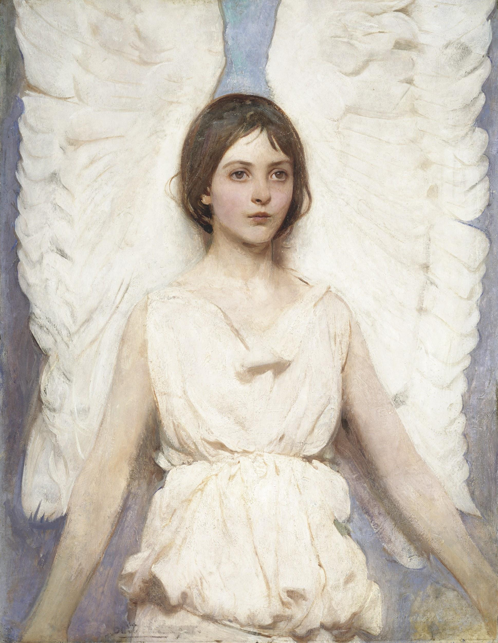

**Easy, Beginner Steps to Channel your Angels!**

**So easy A Kindergartener can do it!**

**By Rebecca Marina**

Before you begin to do this exercise, it is important to take care of your doubts and fears that you won’t be able to do it.

You have two choices:

#1. Watch me SHOW you on this video.

[Watch Me](https://vimeo.com/668806983)

<https://vimeo.com/668806983>

Or

#2. Follow instructions below

Look at the EFT Diagram below and follow along and tap on each one .

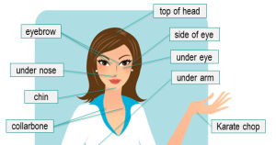

First measure how strong your doubt is. From 1 to 10. Write it down. 10 is a high degree of doubt. It will start to come down as you go.

Tap Side of hand (karate chop spot) and say:

Even tho I have doubt and fear, I love and accept myself. (repeat 3 times)

Then tap top of head and say doubts and fears.

Then tap eyebrow point and say doubts and fears

Then tap under eye and say doubts and fears

Then tap under nose and say doubts and fears

Then tap chin and say doubts and fears

Then tap collarbone and say doubts and fears

Then tap underarm and say doubts and fears

Check in with how strong your doubts and fears are now.

If still high, simply repeat. On a scale of 1 to 10…have they come down?

**After the intensity comes down, you can tap in the POSITIVE affirmation.**

Simply follow the tapping points while repeating, I choose to channel my angels even if I still have some doubt.

When you feel clear, you are ready to begin.

It's important to establish why you desire to Channel, whether it is Guardian Angel, or ANY Being of Light!

Are you seeking specific information for your own personal guidance?

Are you seeking to transmit messages for the benefit of others?

Are you seeking to do this just for fun?

All reasons are valid, good and no cause for shame or embarrassment.

Would you like to know what every Light Being, including Guardian Angel, **wants from you?**

First and foremost, Light Beings including your very own ANGELS want a **relationship with you**, **more** than they want anything else. This is why I recommend that you begin to Channel by establishing a relationship with the Light Being that is your own angels. (Or choose one of the Angels of Easy world)

After all, would you like it if someone just wanted to ask you all kinds of questions, without even getting to know you? That would be very awkward. So always begin by establishing a relationship with any Being whom you wish to Channel.

For The angels... I suggest that you write a greeting to your angel, with your dominant hand, which could possibly say … Dear Guardian Angel, I desire to form a relationship with you. Is that okay?

Now switch the pen into your non-dominant hand, and just be still for a moment. You will get **one or two words** in response, as all spiritual information comes through the right side of the brain.

Your Non-dominant hand is HARDWIRED to the right side of your brain. **Being right or left-handed does NOT affect this phenomenon.** Spiritual Information will ALWAYS come through the right side of your brain first.

**It's very important that you actually write out the question, because there is Magic in the switching.** When you're writing with your dominant hand, and then switch to your non-dominant hand for a response, **something special happens within your brain.**

You are actually creating **New Neural Pathways** between the right hemisphere of the brain and the left hemisphere of the brain. Information is transmitted via the Corpus Callosum, which is the thick bundle of nerves separating and connecting the right and left hemispheres of the brain.

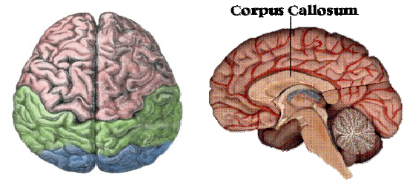

Each time you do this exercise, you are creating more Neural Pathways. Soon, what seemed like a dim narrow path, will become a bright super highway! With practice, you are able to receive Channeled information easily.

The great Light Being, Sanat Kumara, told me in a Channeling session, that the Corpus Callosum is a marvelous map system! This Sensitive Bundle of Nerves already contains a route for every Being of Light or Angel whom you may ever desire to Channel.

As you continue to do this exercise... writing a question with the dominant hand, and then switching the pen to answer with the non-dominant hand... you create more new Neural Pathways. Then information begins to flow very easily and rapidly.

I have been Channeling for many years, and yet, whenever I meet a new Being of Light, who desires for me to Channel information for them... I always take a few days to do dominant/non-dominant handwriting with them.

**This increases the ease of communication exponentially!**

It's important to start out with baby step questions.

As I said earlier, establishing a relationship is KEY.

Below are some questions which I suggest that you use to start. Remember, it's very important to write out the question… even though I've written it for you... and **then** switch to the non-dominant hand to receive the answer.

Remember, this information will come through the right side of your brain. You **will not be possessed by some Spirit** that comes in to move your hand! There is a field of study called “automatic writing” - **this is** **not that study**.

You are not possessed... however, the information does flow into the right side of your brain… perhaps one tiny word at a time.

It's important to be gentle with yourself. Resist the impulse to be impatient. Just take this one baby step at a time.

Also, be cautious of the questions you decide to ask.

**DO NOT be asking fortune-telling questions...**

Question: What is a “fortune telling” question?

Answer: A question that demands that your Angels foretell the future. **Not even God has dominion over the FREE WILL of man.**

There are always humans involved in every decision... and every single one of them has FREE WILL. Therefore it is impossible for any being to accurately predict the future every time. It **IS possible** to make a prediction “based on the energy as it appears now.”

Examples of “fortune telling” questions are:

* **When will my true love come**? He or she has FREE WILL... and you CANNOT impose your will on theirs…
* **When will this situation be resolved?** Again, other people and their FREE WILL are involved.
* **If I play these numbers in the lottery… will I win?**

Oh PLEASE! If you want to Channel ONLY for fortune telling reasons, you can BLOCK the flow of guidance from your Guardian Angel!

**Better questions are: HOW can I accomplish something or... WHAT action can I take toward my goal?**

Example:

* HOW can I get ready to attract my true love?
* WHAT can I DO to resolve this situation?
* WHAT can I DO to win big in life?

Do you see the difference in the questions?

Remember that your Guardian Angel is looking for a relationship and a partnership. When you ask HOW or WHAT... you are taking responsibility for **your part.**

Remember that your Guardian Angel (or ANY Light Being) desires to be of service to humanity... not your puppet!

Also, remember what I said earlier, about being a friend and establishing a relationship. You would not be happy if someone only liked you because of the information that you could give them, would you? Keep that in mind as you begin this exercise...

Now you are ready to begin...

Put your pen into your dominant hand and write out one of these questions.

It is IMPORTANT to write the question with your dominant hand (even though I just wrote it FOR you). There is MAGIC in the actual SWITCHING of your hands! **Don’t cheat yourself of this Magic.**

With your dominant hand, write… **Dear Guardian Angel, I would like to establish a relationship with you. Is there anything that you would like to say to me now?**

Write the question here: ____________________________________________________________________________________________________________________________________________________________

Switch the pen now, and allow information to flow to you… one word at a time. Remember that no Spirit is going to come to move your hand! The Wisdom is coming from Guardian Angel … through the right side of your brain.

Write the response here… Give yourself plenty of room... as you will write big and sloppy. (Notice that the spacing is extra roomy.)

Write Guardian Angel’s response here:

____________________________________________________

____________________________________________________

____________________________________________________

After you have done that part of the exercise... move to another question. Put your pen back into your dominant hand, and write this... **Dear Guardian Angel, is there anything that I can do for you?**

Write the question here: ________________________________________________________________________________________________________

Switch the pen back into your non-dominant hand, and allow the Wisdom to flow... one little word at a time.

Write Guardian Angel’s response here:

____________________________________________________

____________________________________________________

____________________________________________________

I suggest that you repeat these two questions daily, until you begin to feel that the information is flowing more easily.

Expect that you're going to write big and sloppy, with the non-dominant hand. **That is perfectly right and good.**

It's important NOT to criticize yourself. And it's important NOT to be concerned that “nobody could read this”. Nobody else is supposed to read this... except for you. This is your exercise, for your spiritual growth.

This is JUST THE BEGINNING of your relationship with Guardian Angel. It is up to you to continue, and formulate more questions until the information flows more smoothly. As you progress, you may find that you do not need to ask questions at all. Just sit with pen in hand... and invite Guardian Angel to come to you.

You may desire to have more Light on what you have received. Simply repeat the handwriting process asking:

* Will you please give me more clarity on what you said?
* What can I do to communicate with you more effectively?
* Do you see any spiritual or mental blocks? Please let me know what I can do to release/heal them.

I would love to hear some of your experiences with this… so please drop me a line to tell me how you’re doing:

[Rebecca@Rebeccamarina.com](mailto:Rebecca@Rebeccamarina.com)

PS: Be sure and approach this from a fun and playful mind. It will be so much easier than if you strain yourself.